 | ANGLO-CHINESE JUNIOR COLLEGE  JC2 Preliminary Examination  Higher 2

H2 GEOGRAPHY |  | 9173/02
Paper 2 |  | 28 August 2024
Insert |  | 3 hours

READ THESE INSTRUCTIONS FIRST

This Insert contains all the Resources referred to in the questions.

This document consists of 9 printed pages and 1 blank page.

Resource 1 for Question 1

Land use map of the area adjacent to the Punggol Waterway

Site X
Site Y

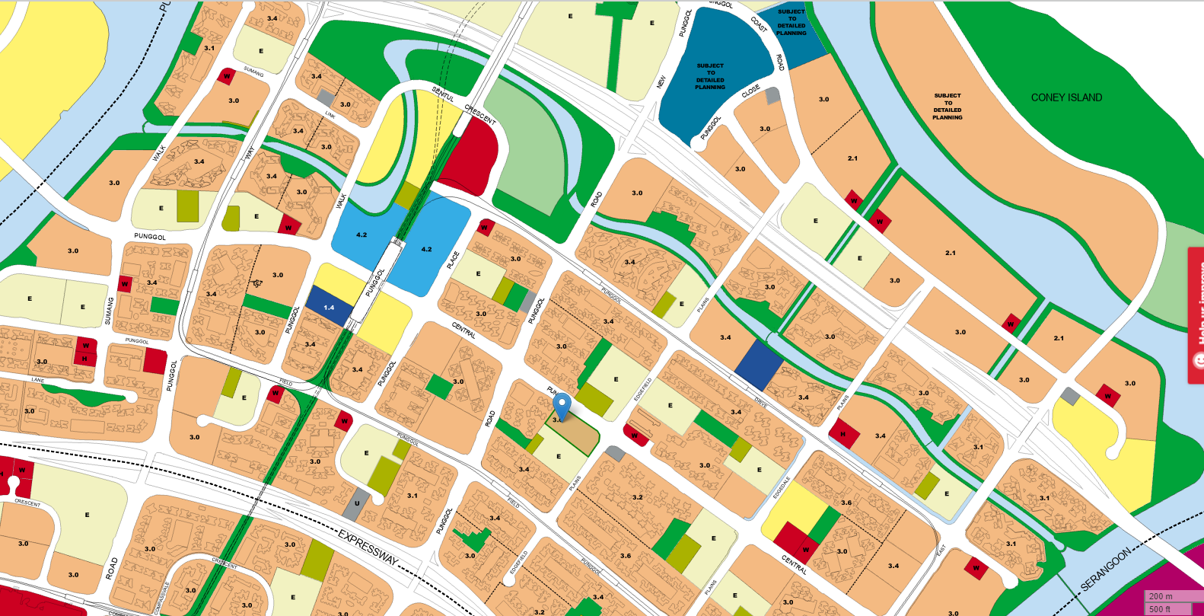
Punggol Waterway Park
SERANGOON RIVER
PUNGGOL RIVER

200 m
Scale:

Map Legend
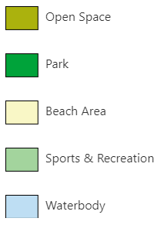 |      | 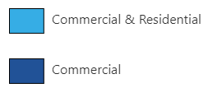    

Resource 2 for Question 1

Photographs of Sites X and Y

The placement of the infiltrometer at each site is marked by a white cylinder in the photographs.

Site X
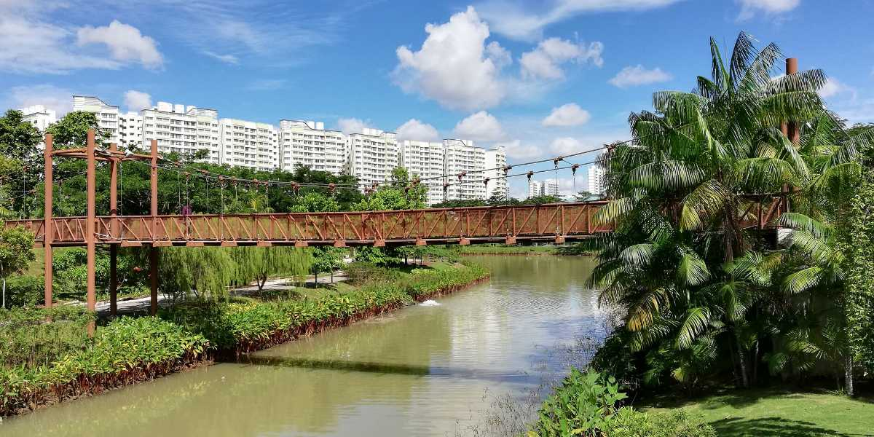

Site Y
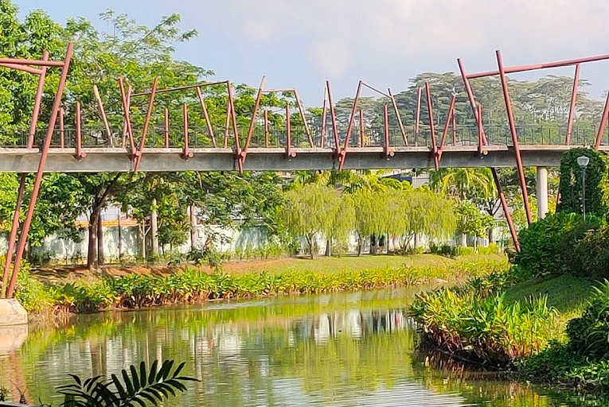

Resource 3 for Question 1

Infiltration rates at Site X and Site Y

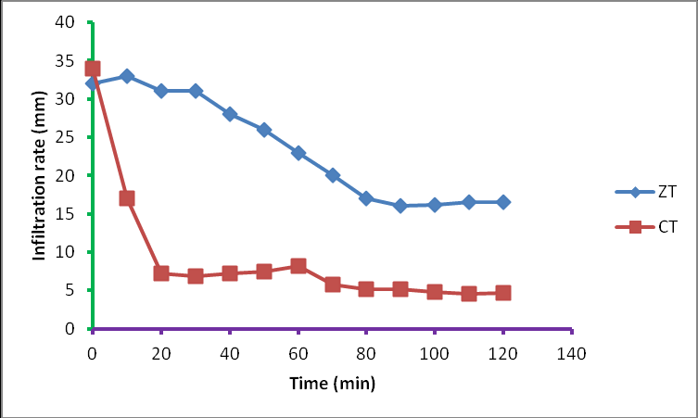
Site Y
Site X
Time since the start of the experiment (minutes)

Resource 4 for Question 1

Results of the river investigation

River cross section at Site X

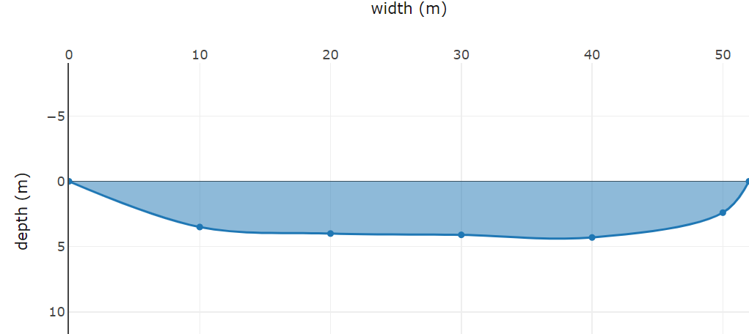
Cross sectional area: 173.4 m²
Wetted perimeter: 53.9 m
Hydraulic radius: 3.22
River velocity: 0.082 metres/sec

River variables at Site Y

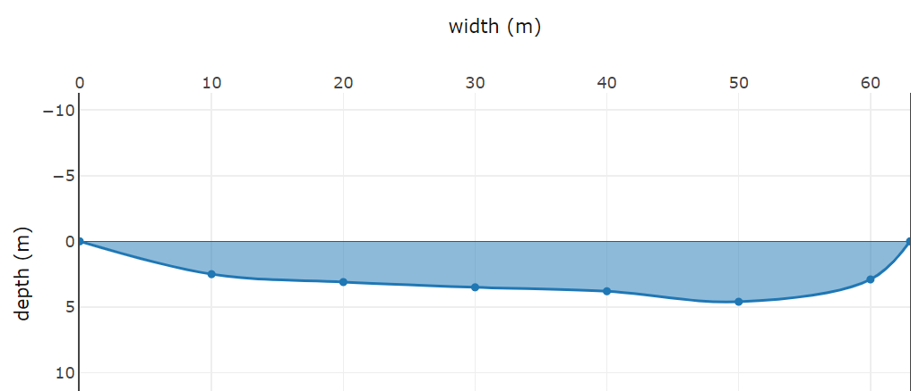

Cross sectional area: 193.8 m²
Wetted perimeter: 67.6 m
Hydraulic radius: 2.9
River velocity: 0.071 metres/sec

Resource 5 for Question 2

Distribution of the Small Island Developing States (SIDS)

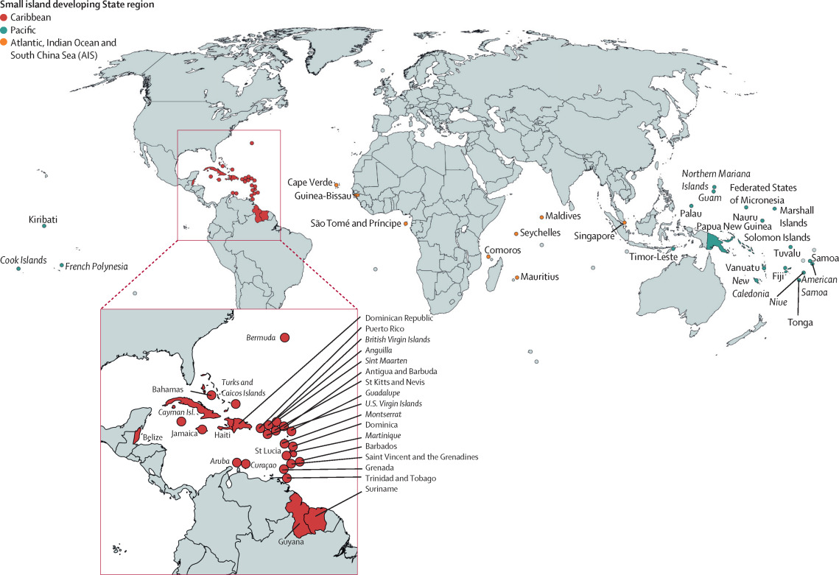

Resource 6 for Question 2

Temperature anomaly* vs sea level rise

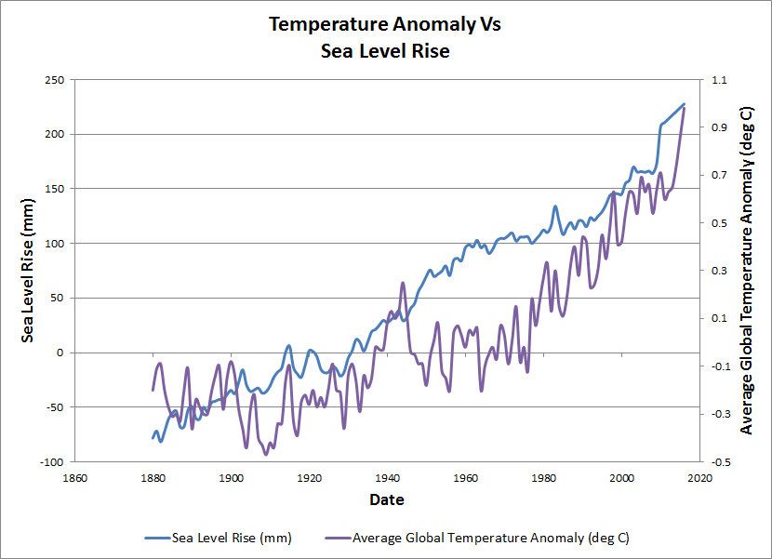

*Temperature anomaly means a departure from a reference value or long-term average. A positive anomaly indicates that the observed temperature was warmer than the reference value, while a negative anomaly indicates that the observed temperature was cooler than the reference value.

Resource 7 for Question 2

The impacts of climate change on aquatic and terrestrial ecosystems

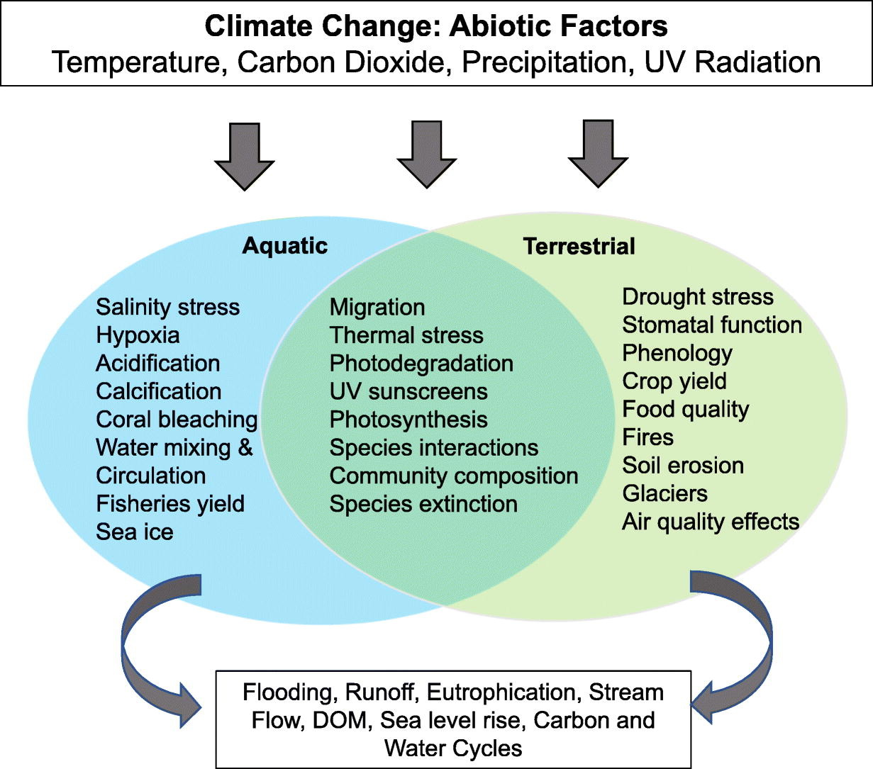

Resource 8 for Question 2

Infographic about the impacts of climate change on SIDS

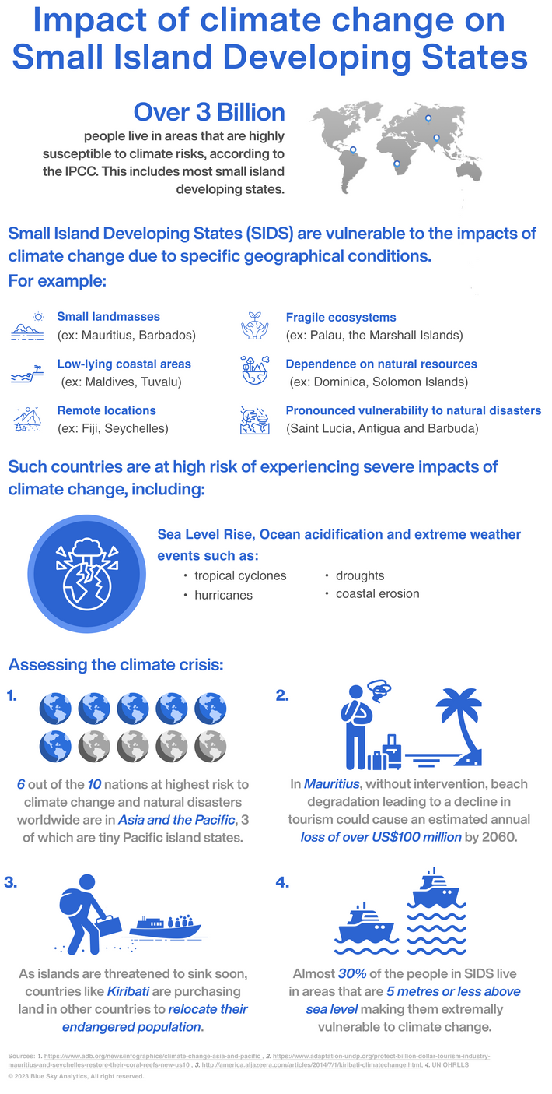

BLANK PAGE

